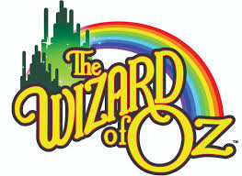
CAST PHOTO & DVD
ORDER FORM

Cast Photograph (includes cast, crew and pit orchestra)
All photos are 8”x10” and cost $15.00 per photo. Photos can be Picked up at the high school. You will be notified via email/phone when they are ready.

DVD Recording
Our production will be professionally recorded (audio/video).
The cost is $25.00 per DVD. DVDs can be picked up at the high school.
You will be notified via email/phone when they are ready.
Audio/Video by Mind’s Eye Music Studios ~ Williamsport, PA
Stone State Entertainment LLC ~ Northumberland, PA

Contact Information
Name
Address
Email
Phone
PHOTO |  | QTY: | X $15 | =
DVD (Fri) |  | QTY: | X $25 | =

Checks are to be made payable to: LAHS Spring Musical

RECEIPT: (Wizard Of Oz – Cast Photo/DVD)

Name: _____________________________________________________________________

Paid $__________ cash check #___________ Date _____ / _____ / _____

